

Year 12 ATAR Human Biology. Nervous & Hormonal Control Task 3

DO NOT WRITE ON THIS BOOKLET

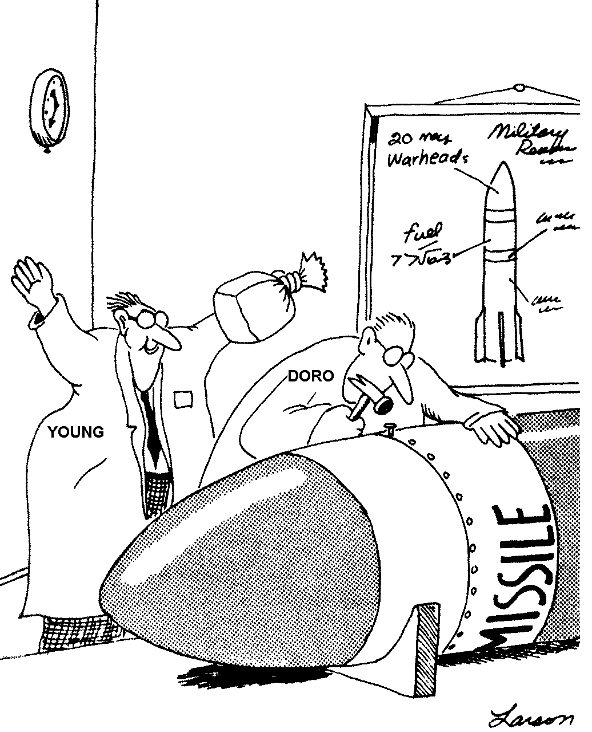

Section A – | Multiple Choice | 20 marks
Section B – | Short Answer | 35 marks
 | Total | 55 marks

SECTION A: MULTIPLE CHOICE (25 marks)

Answer these questions in the separate answer booklet. DO NOT WRITE ON THIS SHEET
Colour in the correct square to indicate your choice in the answer booklet.

1. This question refers to the two situations below.

SITUATION 1: RESPONSE LENGTH OF RESPONSE
Stretching of patellar tendon knee jerk reflex brief

SITUATION 2: RESPONSE LENGTH OF RESPONSE
Witness an accident become shaky long lasting

The reason for the difference in the length of response between SITUATION 1 and SITUATION 2 is
due to

(a) nerve action being fast while hormonal action may be prolonged
(b) the length of the nerve pathways involved
(c) sympathetic versus parasympathetic control
(d) the time it takes for the adrenal cortex to respond

2. In an experiment on mature female rats the pituitary gland was removed. Which of the following would remain UNAFFECTED?

(a) Adrenalin secretion from the adrenal gland
(b) Secretions of oestrogen from the ovary
(c) Thyroxine secretions from the thyroid gland
(d) Water retention from the kidney

3. Hormones are carried by

(a) lymphatic ducts.
(b) nerves
(c) ducts of the endocrine glands.
(d) the blood.

4. Hormones work by

(a) acting on enzymes within the target cell
(b) changing how the enzymes already in the target cell work
(c) acting as receptors in the target cell
(d) allowing enzymes to enter the target cell

5. Which of the structures labelled on the diagram below is responsible for conducting nervous impulses away from the cell body?
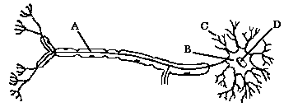

(a) | A
(b) | B
(c) | C
(d) | D

6. Homeostasis is the mechanism by which the body maintains

(a) a dynamic physiological state within an unlimited range
(b) a relatively stable internal environment, within limits
(c) a static physiological state with no deviation from preset points
(d) the lowest possible usage of energy

7. A cluster of nerve cell bodies found outside the central nervous system is known as

(a) a neuron
(b) a synapse
(c) a node
(d) a ganglion

8. The cerebellum assists the body in the maintenance of posture. Other centres feeding information into the cerebellum include

(a) hypothalamus, sensory and motor nerves
(b) medulla oblongata, inner ear and the spinal cord
(c) inner ear and pressure receptors in the skin
(d) eyes, inner ear and, hypothalamus

9. Myelination of a nerve fibre

(a) causes a slower conduction of nerve impulses along the fibre
(b) prevents the nerve impulses from jumping along the fibre
(c) slows the fibre’s return to normal following conduction of an impulse
(d) speeds up the passage of nerve impulses along the fibre

10. The somatic division of the peripheral nervous system is concerned with carrying nerve impulses from

(a) skeletal muscles to the brain via ascending tracts
(b) the brain to internal organs via descending tracts
(c) internal organs to the hypothalamus
(d) the brain to skeletal muscles of the arms and legs

11. Which of the following is NOT a part of the body’s peripheral nervous system?

(a) cranial nerves
(b) spinal nerves
(c) spinal cord
(d) touch receptor

The next two questions refer to the section of the brain illustrated below.

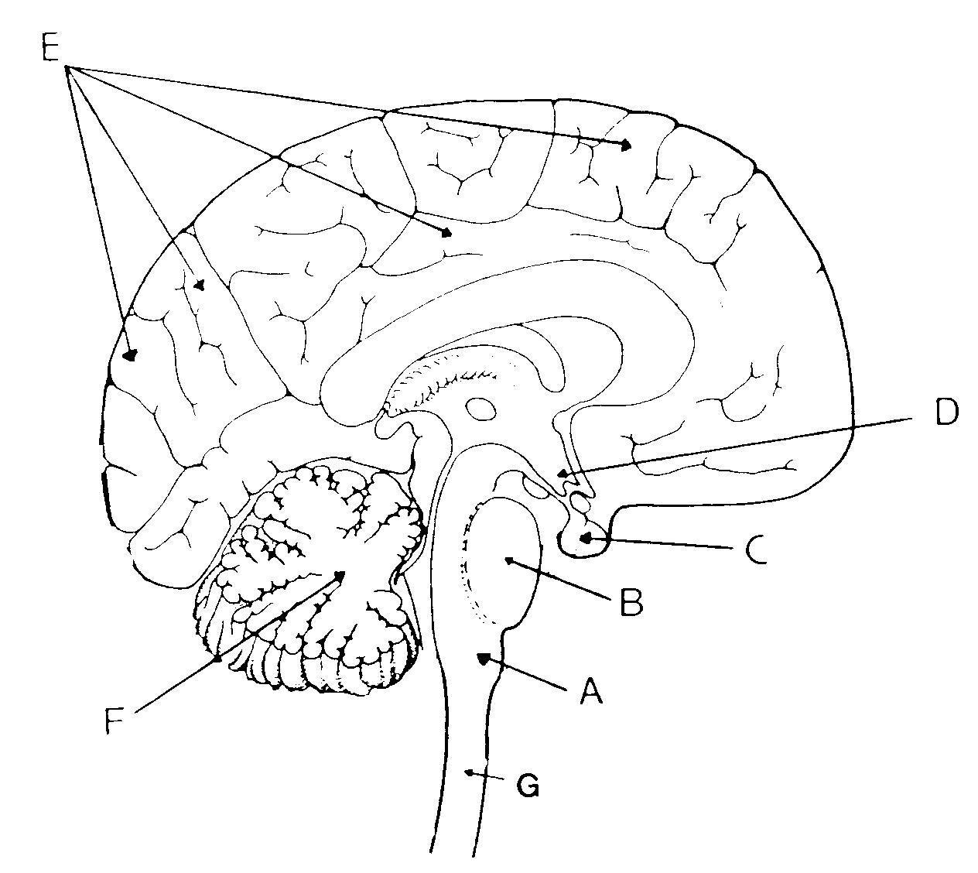

12. Structure E is the

(a) hypothalamus
(b) cerebrum
(c) cerebellum
(d) medulla oblongata

13. The part of the human brain that contains vital centres for regulating heartbeat and breathing is structure:

(a) A
(b) B
(c) C
(d) D

14. The brain is a very delicate organ and as a result needs protection from damage. Which of the following structures does NOT offer protection for the brain?

(a) cranial bones
(b) meninges
(c) myelin sheath
(d) cerebrospinal fluid

Questions 15 and 16 refer to the simplified diagram below of the nerve supply to a toe. Lines A, B, C and D show regions of the nervous system which might be blocked.
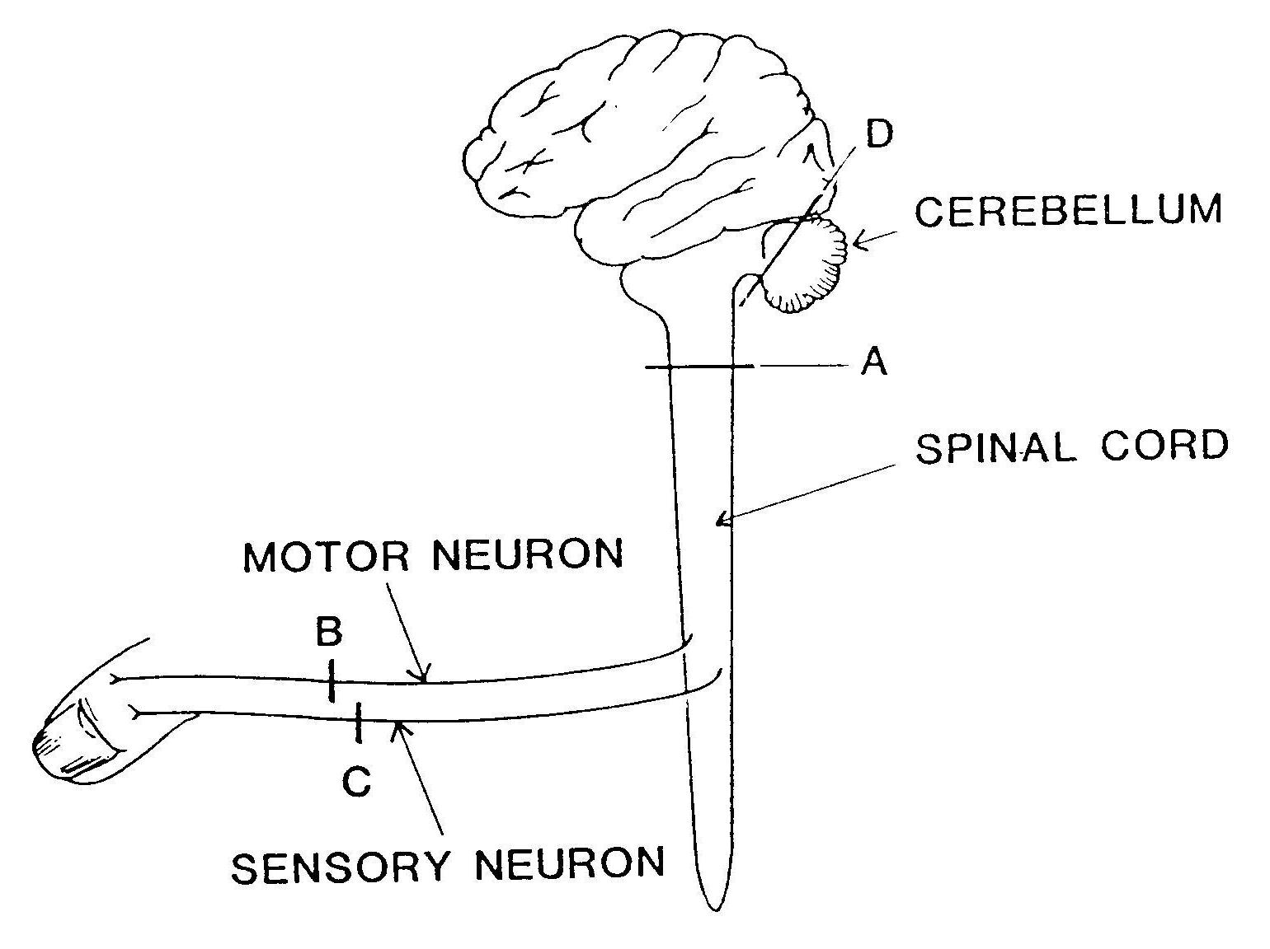

15. If the skin over the toe is stimulated and the stimulus can be felt but the toe cannot be moved then the block is at

(a) A
(b) B
(c) C
(d) D

16. If the toe is stimulated it moves, but neither this movement nor the stimulation can be felt, then the block is at

(a) A
(b) B
(c) C
(d) D

17. Receptors are:

(a) nerve centres in the spinal cord.
(b) centres in the brain that receive nerve impulses.
(c) specialised nervous tissue sensitive to changes in our surroundings.
(d) nerves that conduct impulses within the central nervous system

Questions 18 and 19 refer to the following diagram.

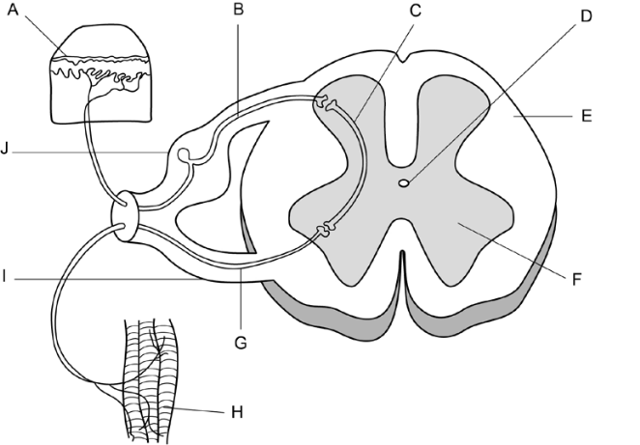

18. Which of the following statements is correct?

- A stimulus is detected by the receptors labelled ‘H’ and transmitted through the
sensory neuron labelled ‘G’.
(b) The motor neuron is labelled ‘G’ and is located in the ventral root labelled ‘I’.
(c) The interneuron is labelled ‘C’ and is located in the white matter labelled ‘F’.
(d) A stimulus is detected by the receptors labelled ‘A’ and transmitted through the
motor neuron labelled ‘B’.

19. The neuron labelled ‘B’ in the diagram can be described as an

(a) afferent neuron carrying information toward the spinal cord.
(b) efferent neuron carrying information away from the spinal cord.
(c) efferent neuron carrying information toward the spinal cord.
(d) afferent neuron carrying information away from the spinal cord.

20. Given the following events:

1. acetylcholine broken down
2. acetylcholine moves across the synaptic cleft
3. action potential reaches the terminal branch (presynaptic terminal) of a motor
neuron
4. acetylcholine combines with a receptor molecule on a skeletal muscle
(postsynaptic membrane)
5. action potential produced in skeletal muscle cell

Choose the arrangement that lists the events in the order they occur at a neuromuscular junction.

a) 2, 3, 4, 1, 5
b) 3, 2, 4, 5, 1
c) 3, 4, 2, 1, 5
d) 4, 5, 2, 1, 3
SECTION B: SHORT ANSWER (35 marks)

Answer these questions in the separate answer booklet. PLEASE WRITE ON THESE SHEETS

21. When the tendon below the knee is tapped with a hammer, the lower leg jerks upwards in a reflex action. A group of students wanted to find out how the speed of the hammer affected the distance the lower leg moved. The diagram below shows how the experiment was set up. Each trial was recorded on a video. A frame was taken every 33 milliseconds. The video was then played using single-frame advance. The number of frames for the hammer to move to the knee was found. The faster the speed, the smaller was the number of frames. The video was also used to find the distance moved by the toe. In each trial, the experimenter held the hammer 20 cm from the subject’s knee then hit the subject’s tendon. For each trial the experimenter used the hammer at progressively increasing speed. The table below shows some of the results.
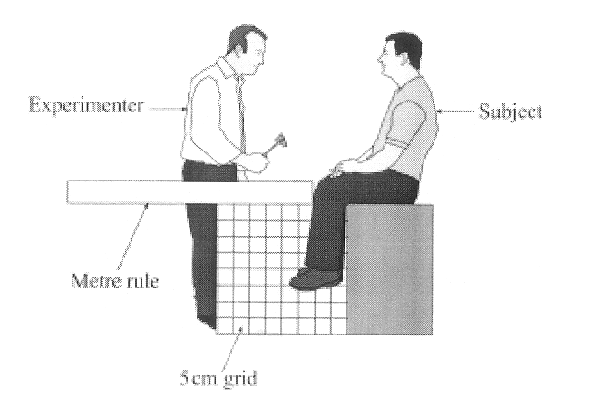

Trial Number | 1 | 2 | 3 | 4 | 5 | 6 | 7 | 8 | 9 | 10
Distance hammer moved to knee (cm) | 20 | 20 | 20 | 20 | 20 | 20 | 20 | 20 | 20 | 20
Number of frames it took the hammer to move to the knee | 15 | 16 | 12 | 10 | 9 | 8 | 7 | 6 | 2 | 2
Distance moved by toe (cm) | 0 | 0 | 5 | 5 | 10 | 10 | 10 | 10 | 15 | 15

- What was the independent variable in this experiment?

_______________________________________________
- mark)

What was the dependent variable in this experiment?

_______________________________________________
(1 mark)

(b) State ONE conclusion that can be drawn from the results.
_______________________________________________

_______________________________________________

(1 mark

(c) Experiments are repeated to enhance their reliability. Describe TWO other ways that this experiment could be changed to improve the reliability of results.

____________________________________________________________

____________________________________________________________

____________________________________________________________
(2 marks)

22.

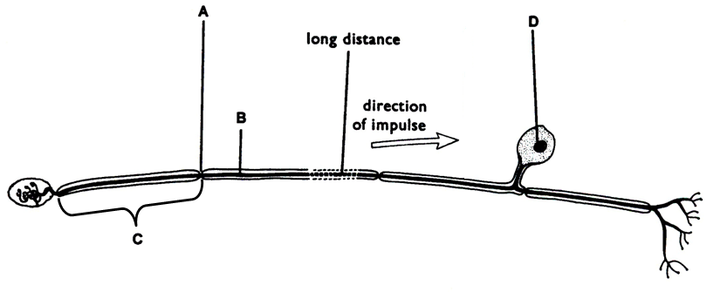

(c) Functionally, what type of neuron is this? _____________________________ (1 mark)

(d) Identify these structures: A __________________________________________

C __________________________________________ (1 mark)

(e) What is the function of structure B? ___________________________________

_________________________________________________________________ (1 mark)

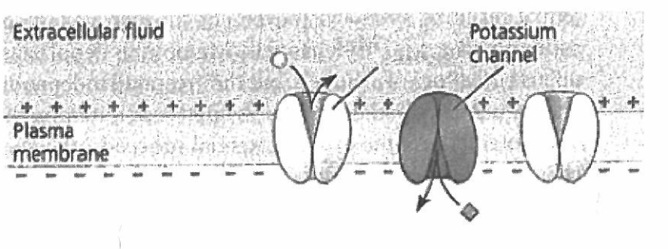
23. Diagram 1
A

The diagram above represents an axon of a nerve cell membrane prior to an action potential occurring.

(a) What substance would be able to pass through structure A when an action potential occurs? (1 mark)

____________________________________________________________________________

Diagram 2

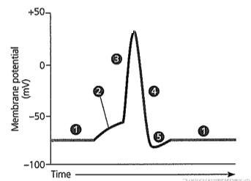
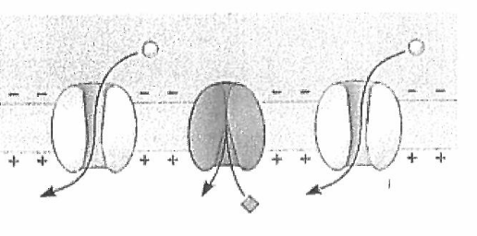

(b) (i) Which part of the action potential shown in the graph above (1, 2, 3, 4, or 5) would
Diagram 2 depict? (1 mark)
____________________________________________________________________________

(ii) What is this called? (1 mark)

____________________________________________________________________________

(iii) Explain the difference between parts 2 and 3 on the graph above. (2 marks)

____________________________________________________________________________

____________________________________________________________________________

____________________________________________________________________________

____________________________________________________________________________

(2 marks)

24. This question refers to the following diagram.

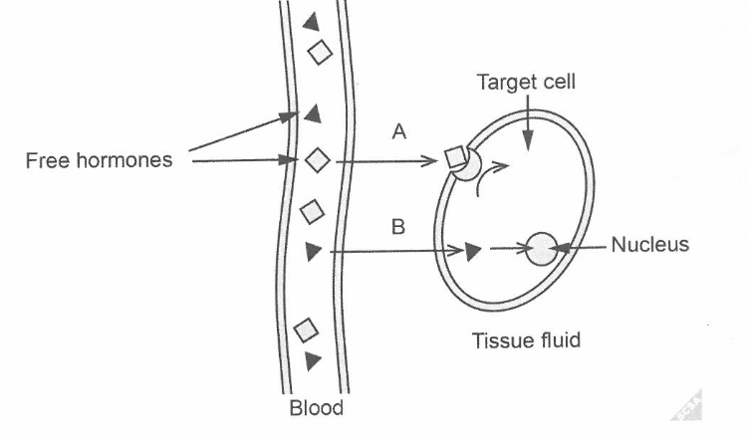
a) A and B are types of hormone
Identify each type and give one example.

A: __________________________________________________________________

B: __________________________________________________________________ (4 marks)

b) Describe two differences between the actions of the hormones.
____________________________________________________________________

____________________________________________________________________

____________________________________________________________________

____________________________________________________________________

____________________________________________________________________
(4 marks)
(c) Ouabain is a substance extracted from an African plant by the Somali people who use it to poison their arrow-heads in order to kill animals. A sufficient concentration of the chemical can bring down a hippopotamus. Scientists now know that Quabain prevents the sodium-potassium pumps in nerve cell membranes from working. What effect would this have on the action potential and why? (2 marks)

____________________________________________________________________________

____________________________________________________________________________

____________________________________________________________________________

____________________________________________________________________________

____________________________________________________________________________

23. On the diagram below, label the endocrine glands in the spaces below. (2 marks)

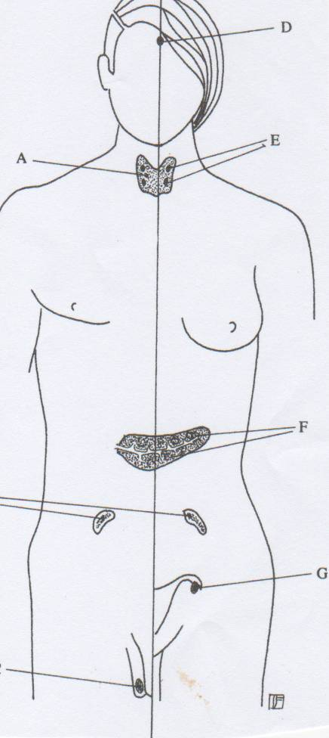

A _____________________________

D______________________________

E______________________________

F______________________________

24. Fill in the table below using the information from the previous question. (4 marks)

Endocrine gland | Product | Effect or function

25. This question refers to the diagram below.

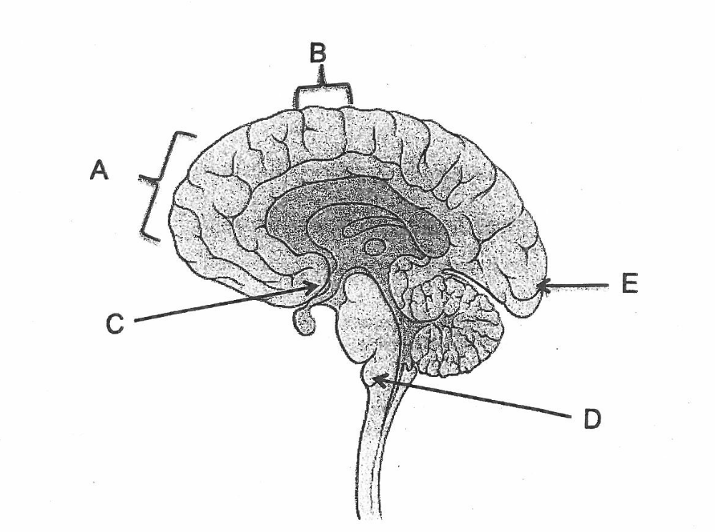

- If an injury occurred in the area E, what sense would be likely to be affected?
__________________________________________________________ (1 mark)
- What lobe of the brain is represented by structure A?
_____________________________________________________________ (1 mark)

- State its function. _______________________________________________ (2 marks)

END OF TEST

Year 12 ATAR Human Biology Task 3 Answer Booklet

Name:

For each question, cross the box to indicate your answer. Use only a blue or black pen to cross the boxes. If you make a mistake, shade through that square then cross your new answer. Do not erase or use correction fluid/tape. Marks will not be deducted for incorrect answers. No marks will be given if more than one answer is completed for any question.

1 | a | b | c | d
2 | a | b | c | d
3 | a | b | c | d
4 | a | b | c | d
5 | a | b | c | d
6 | a | b | c | d
7 | a | b | c | d
8 | a | b | c | d
9 | a | b | c | d
10 | a | b | c | d
11 | a | b | c | d
12 | a | b | c | d
13 | a | b | c | d
14 | a | b | c | d
15 | a | b | c | d
16 | a | b | c | d
17 | a | b | c | d
18 | a | b | c | d
19 | a | b | c | d
20 | a | b | c | d

